Casual Jobs Database V.1

**By:** Supun Chandra Malimage, Kalaivani Ilango & Ruban Ravi Sebastian

**Advisor:** Dr. Steve McKinlay **Client:** Clement Sudhakar Swarnappa

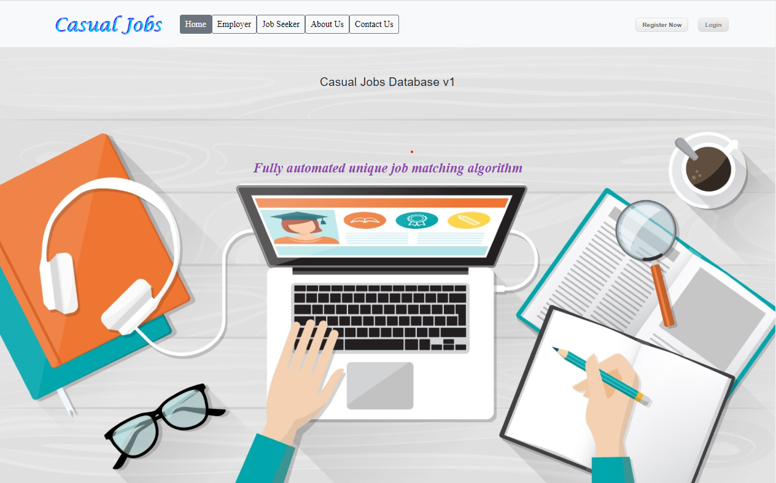 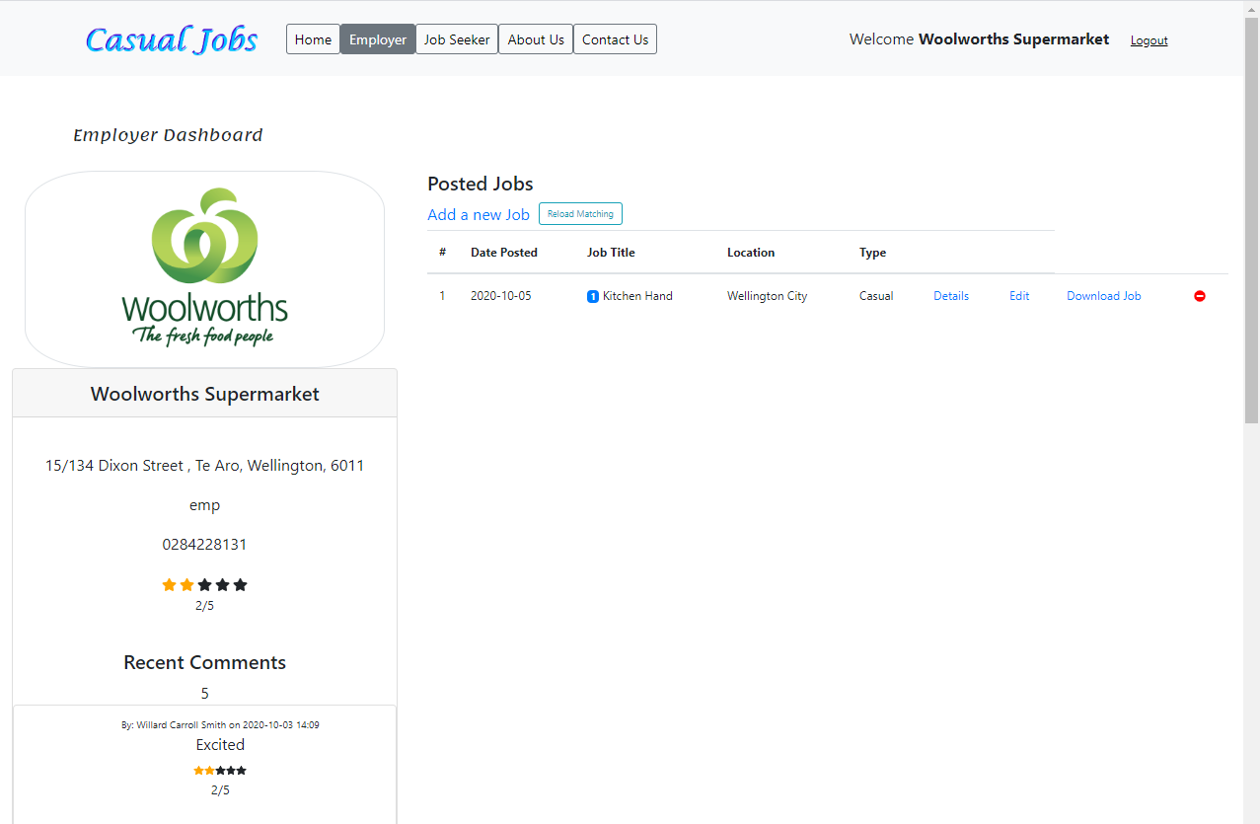 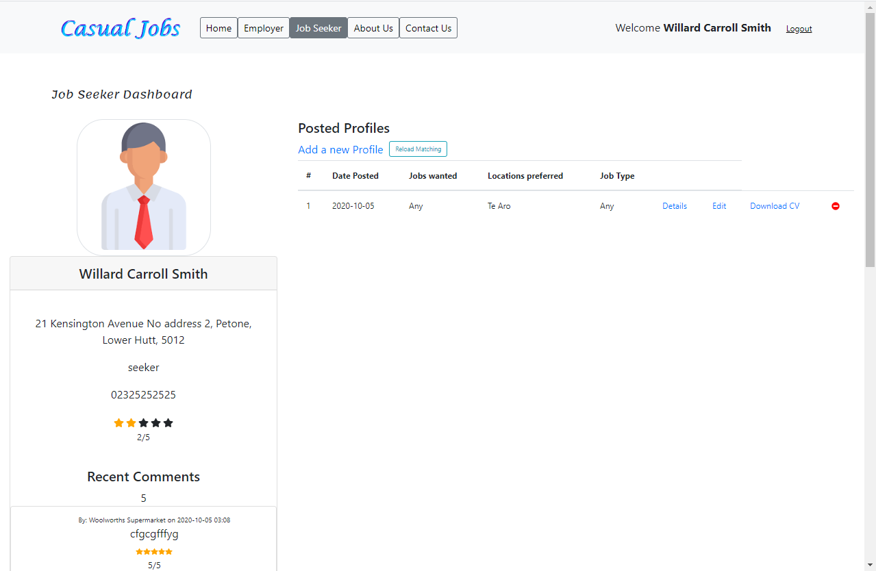

## Home page: Casual Jobs Database V.1 Employer Dashboard Seeker Dashboard

**INTRODUCTION**

This is Casual Jobs Database V.1 web application project. The audience for this project is WelTec academic staff member Clement Sudhakar Swarnappa and the SKR team. Most of the international students are facing difficulties in finding casual employment. This project aims at developing a unique job matching algorithm for employers and job seekers to reduce their time on matching profiles.

This system helps employers to sort candidate profiles in matching percentage weight. The developed system uses a requirement specific keyboard free wizard to automate the job matching. Once the employer shortlist a candidate, the respected job seeker can download the pdf format of job advertisement to know more about the job, as well as employer can see seeker’s CV before shortlist a particular candidate.

**DEVELOPMENT**

* The methodology we used in this project was Rapid Application Development. We got clients’ written approval for each major milestone and continue with 100% clients’ satisfaction.
* We started with research to gather information about the job search applications.
* Created a questionnaire and wireframe to start with front-end development. Parallelly prepared use case, class, activity and ER diagram to develop the database design.
* Developed the job matching algorithm which calculates the weightage between Employer and Job seeker
* Testing has been done in each cycle to make sure the software development is on the right track.
* We have successfully finalized the project 15 days earlier to the expected date and handed over to the client with all the required documents including testing, admin manual and user manual.

**CONCLUSION**

As a team we did our work as best as possible to complete this project by the expected deadline also with the expected quality. As expected, we were able complete the project before the deadline by conserving the highest quality, sustainability, and the reliability. The client was 100% satisfied with all the expected deliverables.

We, SKR team, successfully finalized this project with our teams’ unconditional collaboration and dedication. We appreciate our advisor as well as the client for their kind and remarkable support on solving issues during the project.

Kalaivani Ilango

+64 223469649

Graduate Diploma in IT

I am pursuing Graduate Diploma at WelTec. I did my project on the topic “Casual Jobs Database V.1 “, a unique automated job matching algorithm. I am a Front-end developer. I firmly believe after my studies; I will get a job as a Front-end developer in IT industry. I have a great passion towards programming. In future, I am planning to do Masters in IT and develop my knowledge to the greater extent.

Supun Chandra Malimage

+64 284228131

Graduate Diploma in IT

In July 2020, I have completed major subjects in my studies at WelTec and got highest grade in most of the subjects including System Analysis & Design and Web Application development. I have work experience over 10 years as a Full Stack developer, and great desire on project management and teamwork. Currently I am following Neural Networks and Machine Learning courses. I am happy to share my knowledge with a range of distinguished companies in Wellington once I finish my studies in November 2020.

I am currently doing my Graduate Diploma in Information Technology (Level 7) in WelTec. I have gained great knowledge and experience by doing the Capstone project. I strongly believe that this experience would help me to get into IT industry. I am interested to work as an IT Project Manager, and I am sure I will get it.

Ruban Ravi Sebastian

+64 224977311

Graduate Diploma in IT